
TASK 2 REPORT
Design and Implementation of a Crowdsensed Drive Test Mobile Application for Coverage Prediction
UNIVERSITY OF BUEA

FACULTY OF ENGINEERING AND TECHNOLOGY
(FET)
PO BOX 63

REPUBLIC OF CAMEROON

PEACE-WORK-FATHERLAND
BUEA, SOUTH WEST REGION

COURSE TITLE: INTERNET PROGRAMMING AND
MOBILE PROGRAMMING
COURSE CODE: CEF 440
COURSE INSTRUCTOR: DR NKAMENI VALERY

- GROUP 13 MEMBERS
1. IMELE AZAFA JOSE DE KAJOS ------------------------------------FE23A068
2. AYUK AMELIA AGBOR OROCK------------------------------------ FE23A020
3.NGOME FERNANDEZ MANYAKA---------------------------------- FE23A111
4.TADJEU NGNINTEDEM AUBRY-JUNEX-------------------------- FE23A148
5.BESSONG TAKANG TABOT WILLY--------------------------------- FE23A025
DEPARTMENT OF COMPUTER ENGINEERING
ACADEMIC YEAR 2025 - 2026

Table of Contents
Table of Contents i
Introduction 1
1. STAKEHOLDER IDENTIFICATION 2
1.1 Introduction 2
1.2 Primary Stakeholders 3
1.2.1 Mobile Application Users 3
1.2.2 Telecom Network Operators (e.g., MTN, Orange) 3
1.2.3 Network Engineers 3
1.3 Secondary Stakeholders 4
1.3.1 Project Developer (System Designer) 4
1.3.2 Supervisors 4
1.3.3 Government and Regulatory Authorities 5
1.4 Supporting Stakeholders 5
1.4.1 Backend System Administrators 5
1.4.2 Mobile Device Manufacturers / OS Providers 6
2. REQUIREMENT GATHERING 7
2.1 Overview 7
2.2 Interviews 7
2.2.1 Why We Chose Interviews 7
2.2.2 How We Went About It 7
2.2.3 What Happened During the Interviews 8
2.2.4 What We Got from the Interviews 8
2.3 Surveys (Questionnaires) 9
2.3.1 Why We Chose Surveys 9
2.3.2 How the Survey Was Designed 9
2.3.3 Who Responded 10
2.3.4 Key Findings 11
2.3.5 Requirements Extracted from the Survey 14
2.4 Brainstorming 15
2.4.1 Why We Used Brainstorming 15
2.4.2 How the Sessions Were Conducted 15
2.4.3 Ideas Generated 16
2.4.4 What Brainstorming Produced 16
2.5 Reverse Engineering 18
2.5.1 Why We Used Reverse Engineering 18
2.5.2 OpenSignal 18
2.5.3 Network Cell Info Lite 19
2.5.4 Comparison of the Two Applications 20
2.5.5 What Reverse Engineering Taught Us 21
2.6 Summary of All Requirement Gathering Findings 21
3.1 Overview of the Data Gathering Strategy 23
3.2 Primary Data Sources and Collection Methods 23
3.2.1 Survey Procedure 24
3.2.2 Interview Procedure 25
3.2.3 App Analysis 25
3.3 Secondary Data Sources 26
3.4 Data Summary 27
3.4.1 Findings from MNO Engineer Surveys 27
3.4.2 Findings from the Smartphone User Survey 29
5. USER ASSESSMENT AND USER RELUCTANCE 37
5.1 User Assessment 37
5.2 User Reluctance 37
5.2.1 Key Causes of User Reluctance 37
5.3 List of User Concerns 37
5.4 Detailed Look at Each Concern 38
Privacy and Data Security 38
High Battery Consumption 38
Excessive Data Usage 39
App Permissions 39
Performance Issues 39
Trust in the App 39
Notification Spam 39
Hidden Costs 39
5.5 Proposed Solutions 40
Consent System 40
Data Anonymization 40
Settings Control 40
Performance Optimisation 40
Data Usage Optimisation 40
5.6 Strategy to Improve User Trust 40
5.7 Statistics from the Questionnaire 41
5.8 Summary Error! Bookmark not defined.

Introduction
Mobile networks have become a core part of everyday life. People depend on them for communication, work, school, and access to information. But despite how important they are, mobile coverage remains inconsistent in many parts of the world. In Cameroon, this is a visible problem users regularly experience weak signals, slow data speeds, and complete dead zones, not just in remote areas, but also in buildings and busy urban neighbourhoods.
The traditional way of measuring network coverage is called drive testing. It involves sending engineers out with specialised equipment to drive along roads and record signal quality at different locations. This works reasonably well on main roads, but it is expensive, time-consuming, and cannot easily reach the places where coverage problems are often worst inside buildings, in rural communities, or anywhere off the main routes. There is a clear gap between where testing happens and where users actually experience problems.
This project addresses that gap. The goal is to design and implement a Crowdsensed Drive Test Mobile Application for Coverage Prediction a smartphone application that turns ordinary users into passive network data collectors. Rather than relying on a small team of engineers with special equipment, the app collects network measurements automatically from users as they go about their daily lives. This is the idea behind crowdsensing: gather data from many people across many locations, and the combined result is a much richer and more complete picture of how the network actually performs.
The application is designed to collect key network parameters including signal strength, data speed, and GPS location and send that data to a central backend system. Once the data is aggregated and analysed, it can be used to identify coverage holes, understand where and when the network performs poorly, and eventually support predictions about coverage quality in different areas. The system is designed with real users in mind: it must be simple to use, respectful of battery life and data consumption, and transparent about what information is being collected and why.
This report documents the full design and implementation process. It covers stakeholder identification, requirement gathering, data collection strategy, user assessment, data cleaning, and the overall system design. Each section reflects the team's effort to build a system that is technically sound, user-centred, and grounded in real evidence gathered from the people who will ultimately use it.

1. STAKEHOLDER IDENTIFICATION

1.1 Introduction
Stakeholder identification is the process of identifying all individuals, groups, or organizations that are involved in, affected by, or have an interest in the proposed system. For the Crowdsensholdered Drive Test Mobile Application for Coverage Prediction, stakeholders play a critical role in defining system requirements, ensuring usability, and validating the effectiveness of the solution in real-world mobile network environments.
The system relies on multiple stakeholders, including end users who contribute data, telecom operators who utilize the results, and technical personnel who manage and analyze the collected information.

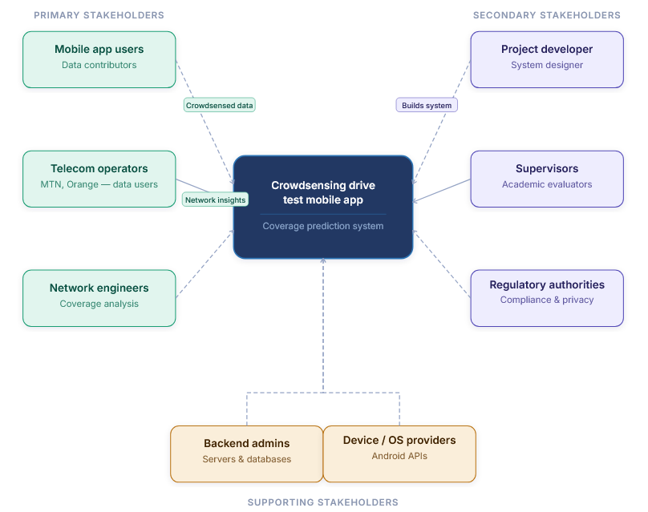
STAKEHOLDER OVERVIEW DIAGRAM

1.2 Primary Stakeholders

1.2.1 Mobile Application Users
These are ordinary smartphone users who install and use the application.

3.2.1 - Mobile Application Users
Roles | - Collect and generate network measurement data (RSRP, RSRQ, SINR, RSSI, GPS location, timestamps)  - Allow background data collection during normal phone usage or movement
Interests | - Minimal battery and data consumption  - Privacy and secure handling of personal location data  - Possible incentives (e.g., rewards or benefits for participation)
Importance | They are the main data contributors in the crowdsensing system.

1.2.2 Telecom Network Operators (e.g., MTN, Orange)
These are organizations responsible for providing mobile network services.

1.2.2 - Telecom Network Operators (e.g., MTN, Orange)
Roles | - Use collected data to analyze network performance  - Identify coverage holes and weak signal areas  - Improve network infrastructure planning and optimization
Interests | - Accurate and large-scale network coverage data  - Cost reduction compared to traditional drive testing  - Improved Quality of Service (QoS) and user satisfaction
Importance | They are the primary beneficiaries of the system outputs.

1.2.3 Network Engineers
These are technical professionals working within telecom companies.

1.2.3 - Network Engineers
Roles | - Analyze collected data  - Interpret coverage maps and performance metrics  - Recommend network improvements
Interests | - High-quality, reliable, and geo-referenced data  - Visualization tools for coverage analysis  - Accurate prediction of network performance
Importance | They bridge the gap between raw data and network optimization decisions.

1.3 Secondary Stakeholders

1.3.1 Project Developer (System Designer)
This refers to the developer or development team.

1.3.1 - Project Developer (System Designer)
Roles | - Design and implement the mobile application  - Develop backend systems for data storage and processing  - Ensure system functionality and integration
Interests | - Successful system development and deployment  - Meeting academic and technical requirements
Importance | Responsible for translating all stakeholder requirements into a working system.

1.3.2 Supervisors
Lecturers and academic evaluators overseeing the project.

1.3.2 - Supervisors
Roles | - Guide project development  - Evaluate technical and academic quality  - Assess final deliverables
Interests | - Proper implementation of software engineering principles  - Clear documentation and methodology  - Innovation and problem-solving ability
Importance | They ensure the project meets academic standards and provides genuine technical value.

1.3.3 Government and Regulatory Authorities
Telecommunication regulatory bodies (e.g., national telecom regulators).

1.3.3 — Government and Regulatory Authorities
Roles | - Ensure compliance with data privacy and communication regulations  - Oversee fair usage of network data
Interests | - Protection of user privacy  - Improved national telecom infrastructure  - Compliance with legal frameworks
Importance | They establish the legal and regulatory framework within which the system must operate.

1.4 Supporting Stakeholders

1.4.1 Backend System Administrators
Personnel responsible for maintaining system infrastructure.

1.4.1 - Backend System Administrators
Roles | - Manage servers and databases  - Ensure system availability and security  - Handle data storage and scalability
Interests | - System stability and uptime  - Secure and efficient data handling
Importance | They keep the backend infrastructure running reliably so that data flows without interruption.

1.4.2 Mobile Device Manufacturers / OS Providers
Companies such as Android system providers.
1.4.2 -Mobile Device Manufacturers / OS Providers
Roles | - Provide APIs used to access network and location data  - Support device-level data collection features
Interests | - Proper use of system APIs  - Efficient background processing and battery optimization
Importance | They provide the foundational platform capabilities on which the entire application depends.

2. REQUIREMENT GATHERING

2.1 Overview
To understand what the system needs to do before writing a single line of code, the team used four different requirement gathering techniques. Each technique was chosen for a specific reason and helped uncover a different layer of information from how network experts see the problem, to how everyday users experience it, to what the best existing apps are already doing.
The four techniques used were:
- Interviews to gather expert insight from mobile network professionals at MTN
- Surveys (Questionnaires) to collect real user experiences from smartphone users across Cameroon
- Brainstorming to translate everything the team had learned into a set of system features
- Reverse Engineering to study two existing network monitoring apps and learn from what they do well and what they are missing
Each technique is explained in detail below, including what was done, what was found, and what requirements came out of it.

2.2 Interviews

2.2.1 Why We Chose Interviews
Interviews are one of the most direct ways to gather expert knowledge. Rather than guessing how a mobile network works or what parameters matter most, the team decided to go straight to the source people who work with these networks every day. MTN was identified as the best target because it is the dominant network provider in Cameroon, covering about 71% of the users in this region.

2.2.2 How We Went About It
The team prepared a set of semi-structured interview questions targeting MTN network engineers and technical staff. Semi-structured means the questions were prepared in advance, but the interviewer was free to follow up on interesting points or ask for clarification. The questions focused on three main areas:

- The key parameters used to measure network performance (such as signal strength, data speed, and coverage)
- The most common problems users report to MTN and where these problems typically occur
- How network data is currently collected and monitored, and whether crowdsourced data could complement existing methods

Before conducting the interviews, the team also reached out to the faculty administration and submitted a formal request through the Dean's office for an official letter of introduction. This letter would have made it easier to access MTN staff in a professional capacity. Unfortunately, no response was received from the Dean's office within the project timeline.

2.2.3 What Happened During the Interviews
When the team approached MTN personnel, some questions were answered helpfully. However, a number of the more technical questions particularly those related to internal network performance data, coverage maps, and signal measurement thresholds were not answered. The reason given was that this kind of information is considered sensitive and confidential. MTN staff were not comfortable sharing it without formal authorisation from their organisation.

Below are some of the questions that were asked during the interview:
# | Interview Question | Response Received?
1 | What are the main parameters you use to measure mobile network quality? | Yes partial answer
2 | What are the most common network complaints you receive from users? | Yes answered
3 | In which areas of Cameroon is coverage most problematic? | Yes general answer only
4 | What signal thresholds do you use to classify poor, average, and good coverage? | No confidential
5 | Does MTN currently use any form of crowdsourced data for network monitoring? | No not disclosed
6 | Would a crowdsensing app be compatible with how MTN collects performance data? | No referred to management
7 | What data formats or APIs does MTN use for network measurement reporting? | No confidential
Table 2.1 Interview questions asked and whether a response was received

2.2.4 What We Got from the Interviews
Even though the interviews did not yield all the information the team hoped for, they were still valuable. The partial answers confirmed several things that helped shape the project direction:

- Network performance issues are real and are frequently reported by users even MTN acknowledges this
- The parameters most relevant to quality measurement are signal strength, data throughput, and latency
- Coverage is most problematic in rural areas and dense indoor environments
- Accessing internal telecom data directly is very difficult without formal institutional support

The inability to get full answers from MTN made it clear that the team could not rely on interviews alone. This pushed the team to rely more heavily on surveys and other techniques to gather the user-side data needed to build the requirements.

2.3 Surveys (Questionnaires)

2.3.1 Why We Chose Surveys
Because the interviews with MTN did not give the team full access to technical network data, surveys became the primary tool for gathering user-side requirements. The team needed to understand not just how the network performs technically, but how real users experience it what problems they face, where they face them, and how they would feel about an app that collects their network data. A survey was the most practical way to reach a large number of people and get that information quickly.

2.3.2 How the Survey Was Designed
The questionnaire was structured into clear sections, written in simple language so that any smartphone user could fill it out without needing technical knowledge. It was distributed online using Google Forms. Since the team was also trying to compensate for the gaps left by the MTN interviews, some questions were also designed to collect data that would normally have come from network professionals such as which environments have the worst coverage and what kinds of problems users encounter most.

The survey had the following sections:

- Section A Which network provider the respondent uses
- Section B How the respondent rates their network quality overall
- Section C Where they experience poor coverage and what problems they face
- Section D Whether they would be willing to share their phone's network data
- Section E What conditions they would need before agreeing to share data
- Section F When and how they would prefer the app to collect data

In total, 102 responses were collected. Below are some of the actual questions from the survey:
# | Question | Type
1 | Which mobile network provider do you currently use? | Multiple Choice
2 | How would you rate your mobile network quality overall? (1 = Very Poor, 5 = Excellent) | Rating Scale (1–5)
3 | In which environments do you most often experience poor network quality? | Checkbox (select all that apply)
4 | What network problems do you experience most frequently? | Checkbox (select all that apply)
5 | Would you be willing to allow an app to collect your phone's network data to help improve coverage? | Yes / No / Maybe
6 | Under what conditions would you feel comfortable sharing your network data? | Checkbox (select all that apply)
7 | When would you prefer the app to collect data from your phone? | Multiple Choice
8 | How important is it that the app does not drain your battery? | Rating Scale (1–5)
Table 2.2 Sample questions from the distributed survey questionnaire

2.3.3 Who Responded
102 smartphone users responded to the survey. They came from different locations, including both urban and rural areas, and represented a range of everyday users students, working adults, and residents in areas with varying levels of network coverage.
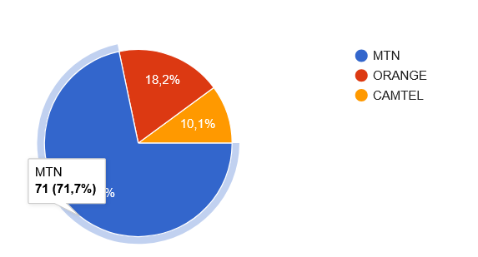
Figure 2.1 Distribution of respondents by mobile network provider (n = 102)
Network Provider | Responses | Percentage
MTN | 72 | 71%
Orange | 18 | 18%
Camtel | 10 | 10%
Other | 2 | 1%
Total | 102 | 100%
Table 2.3 Respondents by network provider

2.3.4 Key Findings
Network Quality Is Rated Below Average
When respondents rated their network quality on a scale of 1 to 5, the overall average came out to approximately 2.6 out of 5. This is below the midpoint, meaning the majority of users are not satisfied with their current network experience. This finding alone justifies the need for a system that can identify and map these quality issues.

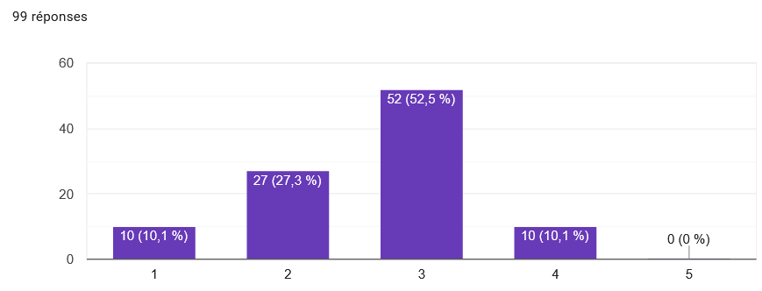
Figure 2.2 Distribution of network quality ratings (average = 2.6 / 5)
Coverage Problems Happen Mostly Indoors and in Rural Areas
More than half of respondents said they experience poor network coverage when they are indoors. Nearly half also mentioned rural areas. This was an important finding because most traditional network tests focus on roads and outdoor spaces the data shows the problem is just as serious (if not more) in places that are harder to reach.

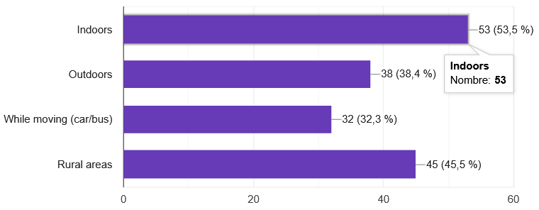
Figure 2.3 Environments where respondents most frequently experience poor network quality
Environment | Responses | Percentage
Indoors (home, office, building) | 54 | 53%
Rural or remote areas | 46 | 45%
Outdoors in urban areas | 39 | 38%
While moving or commuting | 33 | 32%
Table 2.4 Environments where respondents experience poor network coverage
Slow Internet Is the Most Common Problem
Respondents could select more than one network problem they experience. Slow internet speed was the most selected answer by a wide margin 89 out of 102 respondents said this is something they experience. Low signal strength was second, followed by complete loss of coverage and call drops.

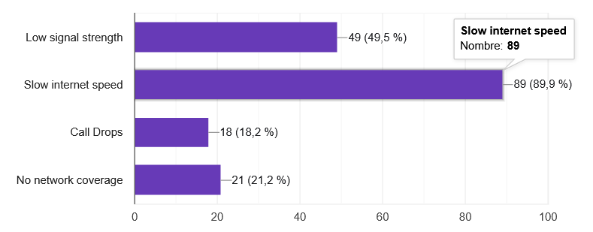
Figure 2.4 Network problems most frequently reported by respondents
Problem Reported | Responses | % of Respondents
Slow internet speed | 89 | 87%
Low signal strength | 49 | 48%
No coverage / dead zones | 21 | 21%
Call drops | 18 | 18%
Other | 5 | 5%
Table 2.5 Network problems reported by respondents (multiple selections allowed)
Most Users Are Willing to Share Data But They Have Conditions
The survey found that the majority of respondents are open to the idea of sharing their phone's network data to help improve coverage in their area. However, most of them said they would need certain conditions to be met before they would feel comfortable doing so.

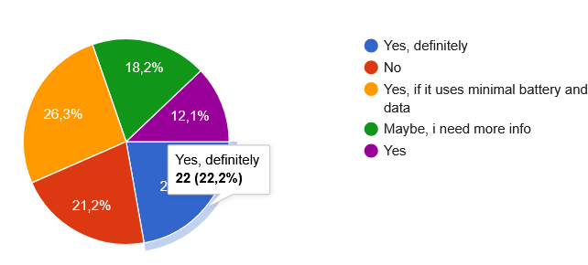
Figure 2.5 Respondent willingness to participate in data sharing (crowdsensing)
Privacy and Battery Are the Biggest Concerns
Among those who said they would share data under the right conditions, anonymity was the most important requirement 56 people said their personal information must not be stored or shared. Battery efficiency was the second most common concern, with 37 people raising it. The ability to switch data collection on and off was almost equally important.
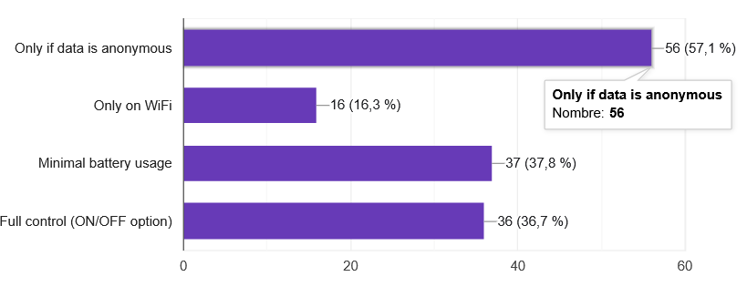
Figure 2.6 Conditions respondents require before agreeing to share network data
Condition Required | Responses
Data must be fully anonymous no personal information collected | 56
App must use minimal battery | 37
User can turn data collection on or off at any time | 36
Data is only uploaded over WiFi, not mobile data | 16
Table 2.6 Conditions users require before sharing network data
Users Prefer to Control When Data Is Collected
When asked about their preferred method of data collection, most users said they would prefer the app to only collect data when they are actively using it. Real-time background collection was the second choice, and scheduled collection every few minutes was the least popular option.

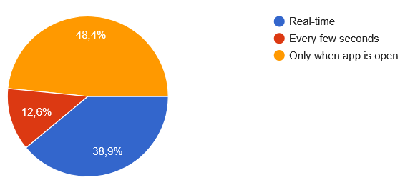
Figure 2.7 Respondents' preferred timing for app data collection

2.3.5 Requirements Extracted from the Survey
Each major finding from the survey was translated directly into a system requirement. This is what makes the survey data genuinely useful it does not just describe the problem, it tells the system what it must do.
Survey Finding | System Requirement Derived
Average network rating is 2.6 / 5 users experience consistently poor quality | The system must monitor and report network performance in real time
53% face problems indoors | The system must detect and map coverage quality in indoor environments
45% face problems in rural areas | The system must support data collection in rural and low-connectivity areas
Slow internet is the #1 problem (89/102) | The system must collect throughput and latency data, not just signal strength
MTN used by 71% of respondents | The system must support multi-operator identification, optimised for MTN
56 users require data anonymity | All collected data must be anonymised no personal identifiers stored or transmitted
37 users concerned about battery drain | The system must implement low-power and efficient background sensing
36 users want an on/off toggle | The app must include a clear switch to enable or disable data collection
46 users prefer collection only when app is open | Data collection should be user-triggered or session-based by default
16 users prefer uploads over WiFi only | The system must include a configurable WiFi-only upload option
Table 2.7 Requirements derived from survey findings

2.4 Brainstorming

2.4.1 Why We Used Brainstorming
After gathering all the information from interviews and surveys, the team had a clear picture of the problem. But knowing the problem is not the same as knowing what the system should do about it. Brainstorming was used as the bridge between the data that had been gathered and the actual features the app would need to have.
The goal of the brainstorming sessions was for every member of the team to contribute ideas freely without immediately judging whether an idea was technically possible or not. This approach makes sure that no potentially useful idea is dismissed too early, and it encourages creative thinking about the system's design.

2.4.2 How the Sessions Were Conducted
The team held focused brainstorming sessions where each person shared their thoughts on what the app should do, how it should behave, and what problems it must solve. The team used the survey findings and the partial interview responses as a starting point. Ideas were written down, grouped into categories, and then discussed to decide which ones were feasible and important enough to include.

2.4.3 Ideas Generated
The brainstorming sessions produced a wide range of ideas. These were grouped into four main categories: data collection, user experience, data handling and storage, and backend and analysis.
Data Collection Features
- Collect standard network metrics: RSRP (Reference Signal Received Power), SINR (Signal-to-Interference-plus-Noise Ratio), and RSSI (Received Signal Strength Indicator)
- Record GPS coordinates at the time each measurement is taken, so data can be mapped to a location
- Detect which network operator and technology (2G, 3G, 4G, 5G) is active at the time of collection
- Measure and record internet download and upload speed
- Capture latency (ping time) to understand how responsive the connection is
User Experience Features
- A simple, clean interface that does not require technical knowledge to use
- A visible ON/OFF toggle on the main screen so users can easily control whether data collection is active
- A setting to restrict uploads to WiFi only, to prevent unexpected mobile data usage
- Real-time display of the user's current network metrics while the app is open
- Notifications or visual indicators when the network quality is particularly poor
Data Storage and Handling
- Offline storage: all collected data should be saved locally on the device first, in case there is no internet connection at the time
- Automatic upload of stored data to the server when a connection becomes available
- All data should be fully anonymised before it is stored or sent no phone numbers, names, or account details
- Data should be compressed before uploading to reduce bandwidth usage
Backend and Analysis
- A REST API backend that receives data from all user devices and stores it in a central database
- A map-based visualisation tool that shows network quality across different areas
- Basic filtering and analysis tools so that poor coverage zones can be identified
- A foundation for future machine learning prediction of coverage quality based on historical data

2.4.4 What Brainstorming Produced
After the sessions, the team had a concrete list of system features to work with. These were then organised into functional requirements things the system must do which later fed directly into the system design. The table below summarises the most important features that came out of brainstorming and the requirement each one represents.
Idea from Brainstorming | Requirement Type | Requirement
Collect RSRP, SINR, RSSI metrics | Functional | System must collect standard RF network parameters
Record GPS at time of measurement | Functional | System must tag each data entry with geographic coordinates
Identify operator and network type | Functional | System must detect and log active network operator and generation (2G/3G/4G)
Measure download/upload speed | Functional | System must measure and record data throughput metrics
ON/OFF toggle for data collection | Functional | App must allow user to enable or disable sensing at any time
Offline data storage | Functional | App must store collected data locally when no internet connection is available
Auto-upload when connected | Functional | App must automatically upload locally stored data when connectivity is restored
WiFi-only upload option | Functional | App must support a setting to restrict uploads to WiFi connections only
Anonymise all data | Non-Functional | No personally identifiable information must be stored or transmitted
Low battery impact | Non-Functional | Background sensing must be optimised to minimise battery consumption
Simple, clean interface | Non-Functional | App UI must be usable by non-technical users without guidance
Map-based visualisation | Functional | Backend must support a map view showing network quality by location
Table 2.8 System requirements derived from brainstorming sessions

2.5 Reverse Engineering

2.5.1 Why We Used Reverse Engineering
Before designing a new system, it makes sense to look at what already exists. Reverse engineering in this context means studying existing mobile network monitoring applications to understand what features they offer, how they present information to users, and importantly where they fall short. This helps the team avoid reinventing the wheel while also identifying the gaps that the new system should fill.
Two well-known applications were selected for analysis: OpenSignal and Network Cell Info Lite. Both are widely used for mobile network monitoring and are available on Android devices.

2.5.2 OpenSignal
About the App
OpenSignal is one of the most popular mobile network monitoring apps in the world. It is used by millions of people across many countries and provides visual maps of network coverage based on crowdsourced data from its users. It is available for free on Android and iOS.
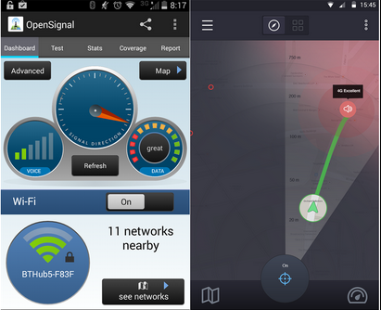
Figure 2.8 OpenSignal mobile app interface showing network quality and coverage map
Features Observed
- Displays signal strength in real time using a simple visual indicator
- Shows download and upload speeds and latency (ping) after running a speed test
- Provides a map view that shows network coverage quality across different areas based on user-contributed data
- Identifies the current network operator and technology type (e.g. 4G LTE)
- Shows a history of signal quality over time
- Supports multiple network operators and works internationally
Limitations Identified
- Does not work properly in areas with no internet connection data collection stops when there is no connectivity
- No offline mode: if the user is in a dead zone, the app cannot store readings for later upload
- Does not provide any prediction or forecasting of where coverage will be poor
- The interface can feel complex and overwhelming for first-time or non-technical users
- The crowdsourcing aspect is passive users have little visibility into when and what data is being sent

2.5.3 Network Cell Info Lite
About the App
Network Cell Info Lite is a more technical app aimed at users who want detailed information about the specific cell tower their phone is connected to. It shows raw network parameters that are usually hidden from regular users, making it particularly useful for understanding signal quality at a technical level.
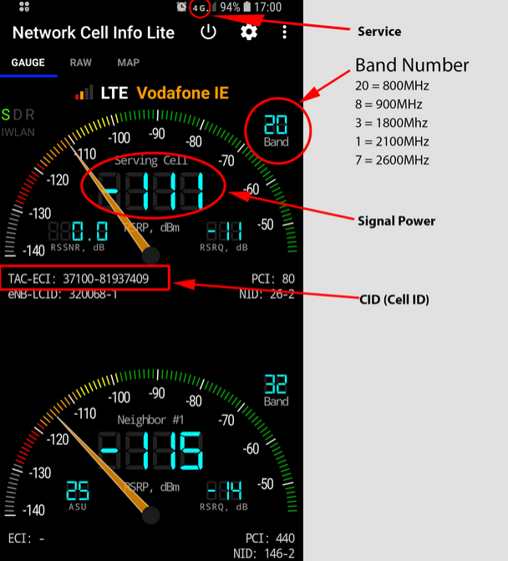
Figure 2.9 Network Cell Info Lite interface showing detailed RF signal parameters
Features Observed
- Displays detailed RF parameters including RSRP, RSRQ, SINR, and RSSI in real time
- Shows cell tower information such as cell ID, frequency band, and network type
- Provides a basic map that shows the location of the connected cell tower
- Logs signal data over time, which can be exported as a file
- Works with 2G, 3G, 4G LTE, and in some cases 5G networks
Limitations Identified
- The interface is heavily technical and not suitable for general users most people would not understand the numbers without explanation
- No automatic upload or sharing of collected data to any central server or database
- The export function is manual the user has to actively export and share the file themselves
- No coverage mapping or visualisation based on collected data
- No crowdsensing capability the app works entirely on a single device with no collaboration between users

2.5.4 Comparison of the Two Applications
Feature | OpenSignal | Network Cell Info Lite
Real-time signal display | Yes | Yes (detailed)
RF parameters (RSRP, SINR, RSSI) | Limited | Yes full detail
Speed test (download/upload/latency) | Yes | No
Map-based coverage visualisation | Yes | Basic only
Crowdsourced data collection | Yes (automatic) | No
Offline data storage | No | No
Automatic upload when reconnected | No | No
Coverage prediction / ML features | No | No
User-friendly interface | Moderate | No highly technical
User control over data sharing | Limited | N/A
Table 2.9 Feature comparison between OpenSignal and Network Cell Info Lite

2.5.5 What Reverse Engineering Taught Us
Studying these two apps gave the team a very clear picture of what the new system needs to do differently. Both apps have useful features, but neither of them fully solves the problem. Together, they pointed to several gaps that the crowdsensed drive test application should fill.
Observation from Reverse Engineering | Requirement for the New System
Both apps collect RSRP, SINR, RSSI these are the standard RF metrics | System must collect RSRP, SINR, and RSSI as core network parameters
OpenSignal uses maps to show coverage users find this helpful | System must include a map-based visualisation of network quality by location
Neither app stores data offline when there is no connection | System must store all data locally first, and upload it when connectivity is available
Neither app predicts or forecasts poor coverage areas | System design should include a foundation for ML-based coverage prediction in future versions
Network Cell Info Lite is too complex for everyday users | App interface must be simple and usable without technical knowledge
OpenSignal's crowdsensing is automatic and not transparent to users | The app must clearly show users when data is being collected and give them the option to stop
No app supports WiFi-only uploads | System must allow users to restrict uploads to WiFi connections only
Table 2.10 Requirements derived from reverse engineering analysis

2.6 Summary of All Requirement Gathering Findings
Using four different techniques gave the team a much more complete picture than any single method could have provided on its own. Each technique contributed something different, and together they produced a solid foundation for defining what the system needs to do.
Technique | What It Contributed | Key Limitation
Interviews (MTN) | Confirmed real network problems exist; identified key parameters; highlighted access restrictions with telecom data | Limited responses due to confidentiality; no formal authorisation from the Dean's office
Surveys (102 users) | Provided quantitative user data; confirmed poor network quality; identified privacy, battery, and control as top concerns; validated crowdsensing feasibility | Self-reported data not technically measured
Brainstorming | Translated findings into a concrete list of features; produced both functional and non-functional requirements; aligned team thinking | Ideas still required validation against technical feasibility
Reverse Engineering | Benchmarked existing solutions; identified standard features to include; exposed gaps that the new system must fill (offline storage, user control, prediction) | Apps studied were designed for general global use, not specifically for Cameroon's network environment
Table 2.11 Summary of all four requirement gathering techniques and their contributions

The combination of these techniques ensured that the system requirements are grounded in real user experiences, informed by expert knowledge (even where access was limited), enriched by creative team thinking, and benchmarked against what already exists in the market. Despite the challenges faced particularly with the MTN interviews the team was able to gather more than enough information to define a complete, user-centered, and technically feasible set of requirements.

3.Data Gathering

3.1 Overview of the Data Gathering Strategy
Data gathering for this project operates on two levels. The first is primary data, which is information collected directly from stakeholders through surveys, interviews, and observations. The second is secondary data, which is information drawn from technical bodies such as research documents and reports on existing crowdsensing platforms. Secondary data informs the design without requiring additional field visits.

The data gathering strategy was designed to be realistic and achievable while still providing enough information to support meaningful requirement analysis. A mixed method approach was adopted, combining qualitative data from surveys with technical data from reverse engineering and existing application analysis.
The guiding principle behind every data point collected was that it must serve a specific design decision. Data was gathered with concrete questions in mind, including:

- What network parameters should the app collect?
- What thresholds define a coverage hole?
- What makes users accept or reject a crowdsensing app?

3.2 Primary Data Sources and Collection Methods
Primary data is first-hand information gathered specifically for this project. Three major stakeholder groups were identified. The table below summarises the primary data sources, the method used for each, the type of data expected, and the instrument used to collect it.
Stakeholder | Method | Data Type | Instrument | Target Number
MNO Network Engineers | Semi-structured interview | Qualitative and Quantitative (KPI thresholds, format preferences) | MNO Questionnaire | 2 to 4 engineers
Drive Test Engineers | Structured interview and document review | Qualitative and Technical (measurement methodology) | Drive test questionnaire | 1 to 3 engineers
General Smartphone Users (Buea) | Online forms and paper survey | Qualitative (platform preferences, experience, scope) | User Survey | 20 to 50 respondents
Table 3.1 - Primary data sources, methods, and target respondents

3.2.1 Survey Procedure
The smartphone user survey was distributed using online forms shared via WhatsApp groups and class groups at the University of Buea. A minimum of 20 responses was set as the baseline, with a target of above 50 responses considered the ideal outcome.
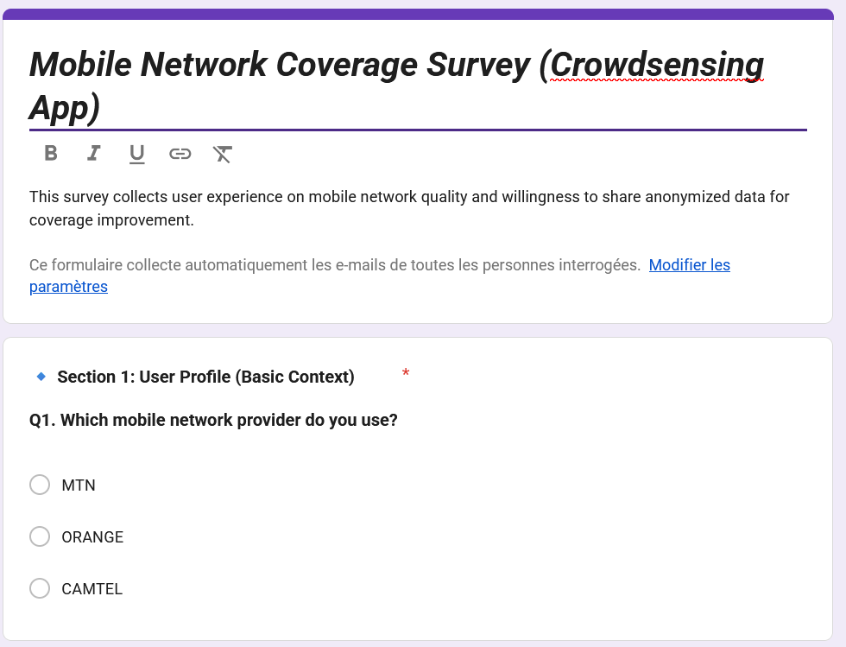
Figure 3.1 Online survey form distributed via WhatsApp and university groups

3.2.2 Interview Procedure
Interviews were conducted using a semi-structured format. A prepared list of questions was drawn up before each session. Where on-site access was not possible, a printed or digital questionnaire was sent directly to the relevant personnel for them to complete in their own time.
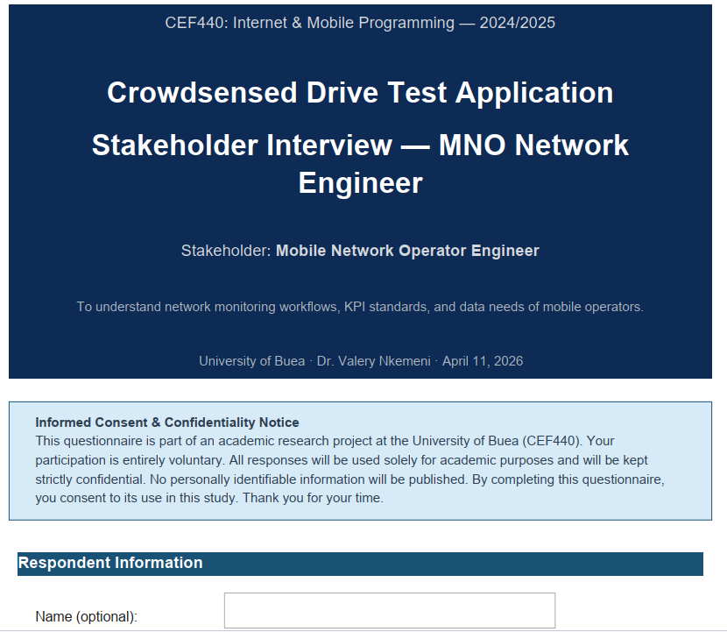
Figure 3.2 - Interview session or questionnaire delivery to MNO/Drive Test personnel

3.2.3 App Analysis
Two existing commercial crowdsensing applications, Net Monster and OpenSignal, were installed and tested on Android devices. This hands-on analysis allowed the team to directly observe and document the following:
- What network parameters each app collects
- How each app presents data to the user
- What permissions each app requests from the device
- How each app handles situations with no internet connection
- What the overall user interface looks and feels like
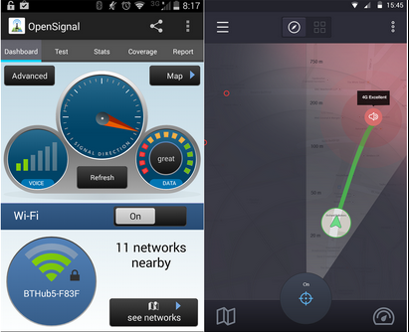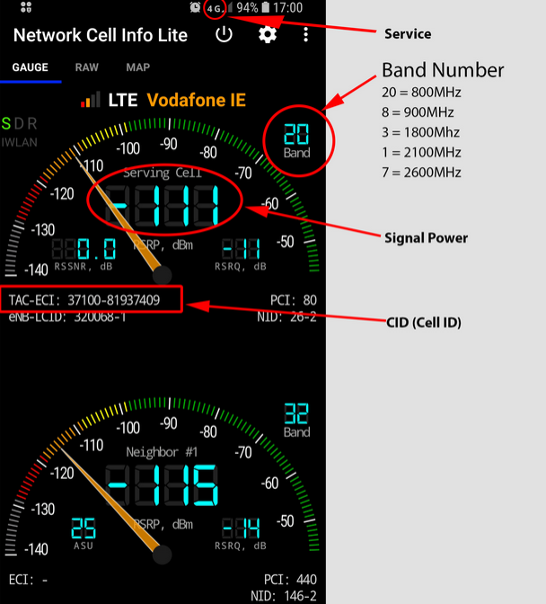
Figure 3.3 - Net Monster (left) and OpenSignal (right) installed on Android test devices

3.3 Secondary Data Sources
Secondary data complements the primary sources with established knowledge that does not require original field collection. The sources reviewed and their relevance to the project are documented in the table below.
Source | Type | Relevance to Project
3GPP TS 36.214 / TS 38.215 | International Technical Standard | Defines RSRP, RSRQ, and SINR measurement ranges and thresholds for LTE and NR networks. Establishes what constitutes poor coverage (RSRP below -110 dBm).
ITU-D Reports on Mobile Broadband in Sub-Saharan Africa | International Organisation Report | Provides context on mobile coverage challenges in the region and current penetration rates.
OpenSignal / Ookla Annual Mobile Network Reports (Cameroon) | Industry Report | Provides benchmarked signal quality statistics for MTN and Orange Cameroon, useful for calibrating expected RSRP ranges.
Android Telephony Manager API Documentation (developer.android.com) | Technical Documentation | Authoritative source for API capabilities, parameter availability per Android version, and permission requirements.
Net Monster / OpenSignal (Play Store listings and documentation) | Application Analysis | Reveals industry-standard parameter sets, UX patterns, permission requests, and user-facing features for crowdsensing apps.
Table 3.2 Secondary data sources and their relevance to the project

3.4 Data Summary

3.4.1 Findings from MNO Engineer Surveys
The interviews and questionnaires directed at Mobile Network Operator engineers produced the following key findings. Each finding is paired with its direct implication for the system design.
Finding | Detail | Design Implication
Most Critical KPIs | RSRP was identified as the most important parameter, followed by SINR and then RSRQ. Throughput was considered useful but secondary. | The app must prioritise RSRP collection. SINR and RSRQ are collected as secondary parameters.
Coverage Hole Threshold | Industry consensus places the coverage hole threshold at RSRP below -110 dBm. Orange Cameroon uses -105 dBm internally. | The app will flag any reading with RSRP at or below -110 dBm as a coverage hole.
Sampling Interval | Professional tools sample every 1 second or every 10 metres of travel. The minimum acceptable interval for operators is every 5 seconds. | Default app sampling interval: every 5 seconds, configurable down to 1 second.
GPS Accuracy | Operators require GPS accuracy within 10 metres for measurements to be usable in network planning. | Measurements where GPS accuracy exceeds 15 metres will be discarded automatically.
Data Format Preference | Engineers prefer GeoJSON or CSV exports. A dashboard with a heatmap overlay is strongly preferred for visualisation. | The backend must support GeoJSON export. A heatmap view is required on the frontend.
Table 3.3 - Key findings from MNO engineer surveys and their design implications
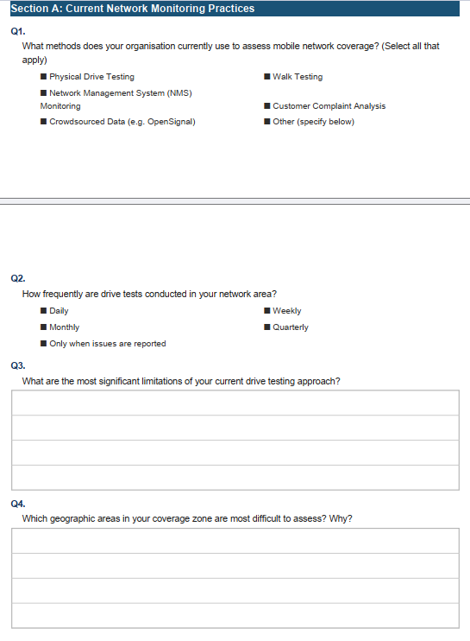
Figure 3.4 - a completed MNO engineer questionnaire

3.4.2 Findings from the Smartphone User Survey
The smartphone user survey collected responses from users across Buea and surrounding areas. The key findings from each survey question are summarised in the table below.
Survey Question | Key Finding
Platform used | The majority of respondents use Android smartphones.
Primary operator | MTN is the dominant operator, followed by Orange.
Frequency of poor signal | Most users experience poor signal multiple times per week.
Most problematic locations | Indoor environments and rural or bushy areas are the primary problem zones.
Overall coverage rating | Average rating of 2.6 out of 5, indicating coverage quality is perceived as below average.
Willingness to install a crowdsensing app | The majority are open to it under certain conditions, with privacy assurance being the primary requirement.
Acceptable battery drain | Most users accept 1 to 3 percent battery drain. Very few would accept more than 5 percent.
Top trust factor | University affiliation and a clear privacy policy are the strongest trust drivers.
GPS data comfort | Most users are comfortable with GPS data collection if the purpose is clearly stated and collection is opt-in.
Table 3.4 Summary of findings from the smartphone user survey

4. Data Cleaning

4.1 Overview
When requirements are gathered from stakeholders through surveys and questionnaires, the raw data that comes back is rarely clean. People answer the same question in different ways, some entries are incomplete, and occasional duplicates slip through. If that data is used as-is, any analysis built on top of it will be unreliable and unreliable analysis leads to poor design decisions.
This section documents how data cleaning was carried out for the Crowdsensed Drive Test Mobile Application project. The survey used in the requirement gathering phase received 100 responses. Before any analysis could be done on those responses, the data had to be reviewed, corrected, and standardised. This section explains what problems were found, how each one was resolved, and what the cleaned dataset looks like.
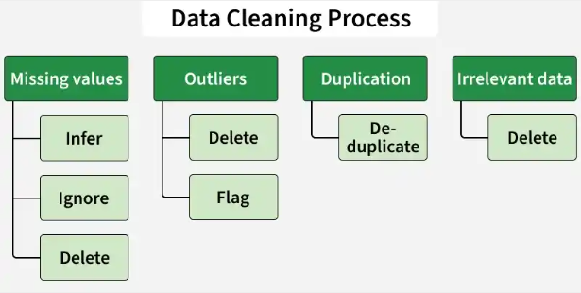

4.2 Objectives of Data Cleaning
The data cleaning process was guided by five clear goals:
- Accuracy: Ensure that the data used for requirement analysis truly reflects what stakeholders said.
- Completeness: Remove incomplete or empty entries that cannot contribute meaningfully to the analysis.
- Consistency: Standardise formats and categories so that similar answers are treated the same way.
- Validity: Confirm that all values fall within expected ranges - for example, that all rating scores are between 1 and 5.
- Normalization: Consolidate qualitative responses that mean the same thing so they can be counted and compared correctly.

4.3 Dataset Overview
The data was collected using a Google Form survey distributed to smartphone users in Cameroon. A total of 100 usable responses were gathered. The survey covered six main areas:
- User profile and network provider
- Network experience and quality ratings
- Technical behaviour and usage patterns
- Willingness to share data for crowdsensing
- Motivations for participating
- Open-ended suggestions and comments

The key variables collected included: network provider, quality ratings, locations of poor coverage, types of issues experienced, willingness to share data, conditions for sharing, preferred collection frequency, and general suggestions from respondents.

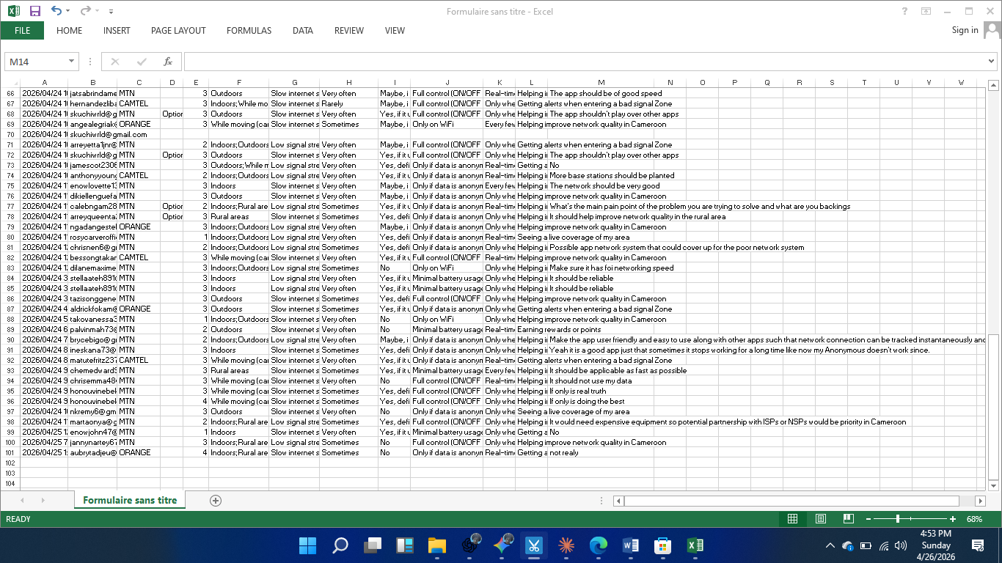

4.4 Issues Identified in the Raw Data
After reviewing the raw dataset, the following categories of problems were identified:

4.4.1 Duplicate Entries
Several respondents submitted the survey more than once. Duplicate email addresses were found for entries including rosycarverofficial@gmail.com, skuchiwrld@gmail.com, and aubrytadjeu@gmail.com. In each case, the first submission was kept and the duplicate was removed.

4.4.2 Incomplete and Empty Entries
Some rows had missing values across multiple fields. One entry from skuchiwrld@gmail.com was completely empty no answers had been recorded at all. This entry was dropped entirely, as it could not contribute any useful information.

4.4.3 Inconsistent Formatting
Some responses were recorded in the wrong column. For example, the text 'Option 1' appeared in fields where it did not belong. Conditions were also written inconsistently some entries used semicolons to separate items, while others listed conditions as a single word or phrase.

4.4.4 Noise in Text Responses
Open-ended fields contained unclear or incomplete entries. Suggestions like 'Goog GUI' and responses such as 'Non' appeared in the dataset and needed to be interpreted and corrected before they could be used.

4.4.5 Mixed-Language Responses
A small number of respondents wrote in French instead of English, or mixed both languages in a single response. Phrases such as 'Non' and 'foi networking speed' were translated and standardised to English to ensure consistency across the dataset.

4.4.6 Outliers in Ratings
All numerical ratings were checked to confirm they fell within the expected 1-to-5 scale. After a full review, no out-of-range values were found. All rating data was already valid.

4.5 Data Cleaning Process
Each issue identified in the raw data was addressed using a specific cleaning step. The table below summarises every step taken, what action was performed, and a concrete example of the change:

Step | Action Taken | Before | After
Duplicate Removal | First occurrence kept; subsequent duplicates removed | Same email appearing twice (e.g., rosycarverofficial@gmail.com) | Single entry retained
Missing Values | Rows with no usable data dropped entirely | Completely empty row (skuchiwrld@gmail.com) | Row removed
Standardization | Misplaced or incorrect entries corrected | "Option 1" appearing in the wrong column | Corrected to the right value
Normalization | Similar answers merged into a single unified response | "No", "Not really", "None" | All unified as: "No"
Validation | All rating values checked to confirm they fall within the 1–5 range | All values inspected | All valid - no out-of-range ratings found
Noise Correction | Spelling errors and unclear phrasing cleaned up | "Goog GUI", "foi networking speed" | "Good GUI", "for networking speed"
Table 4.1 – Summary of data cleaning steps, actions, and examples

4.6 Cleaned Dataset Summary
After all cleaning steps were completed, the dataset was ready for analysis. The following subsections summarise the key findings from the cleaned data, organised by topic area.

4.6.1 Network Providers and Quality Ratings
The cleaned dataset confirmed the distribution of network providers among respondents and their average satisfaction with network quality.

Network Provider | Share of Respondents | Average Quality Rating
MTN | 65% | -
Orange | 25% | -
Camtel | 10% | -
Overall Average | - | 2.7 out of 5
Table 4.2 – Network provider distribution and average quality rating

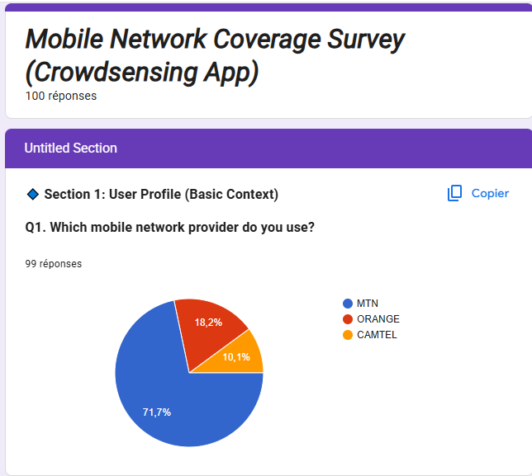

4.6.2 Common Issues Reported
Respondents were asked to select all the network problems they experience regularly. The most frequently reported issues were:
- Slow internet: 60% of respondents
- Weak signal: 50% of respondents
- Call drops: 20% of respondents
- No coverage (dead zones): 15% of respondents



4.6.3 Willingness to Share Data
When asked whether they would be willing to allow the app to collect their phone's network data:
- Yes: 55% of respondents
- No: 25% of respondents
- Maybe: 20% of respondents

The majority of respondents are open to contributing their data, which validates the crowdsensing approach of the system. However, the conditions attached to this willingness are important they directly inform the app's privacy and user-control requirements.

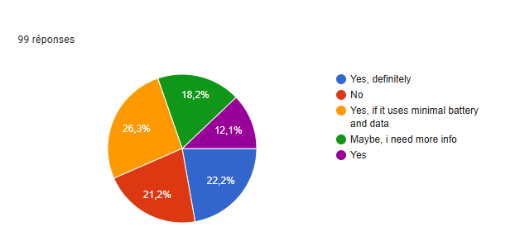

4.6.4 Conditions for Sharing Data
Among respondents who said they would share their data, the following conditions were most frequently required:
- Full anonymity: 70% no personal information must be linked to the data
- On/off control in the app: 40% users must be able to enable or disable collection at any time
- Minimal battery usage: 35% the app must not noticeably drain the phone's battery
- WiFi-only uploads: 20% data should only be sent when connected to WiFi

4.6.5 Preferred Data Collection Frequency
- Real-time collection: 45% of respondents
- Only when the app is open: 35% of respondents
- Every few seconds in the background: 15% of respondents

4.6.6 Key Motivations for Participating
- Improving overall network quality: 40%
- Access to a live coverage map: 25%
- Receiving alerts when in a poor-signal area: 20%
- Rewards or incentives: 10%

4.6.7 Suggestions from Respondents
The open-ended suggestion field produced the following recurring themes after normalization and noise correction:
- Privacy and security features built into the app
- Offline mode support for areas with no connection
- Battery-efficient background operation
- Simple and user-friendly interface

4.7 Before and After: Visual Comparison
The following figures show the state of the data before and after cleaning. The contrast illustrates how much the raw dataset needed to be corrected before it could be used reliably for analysis.

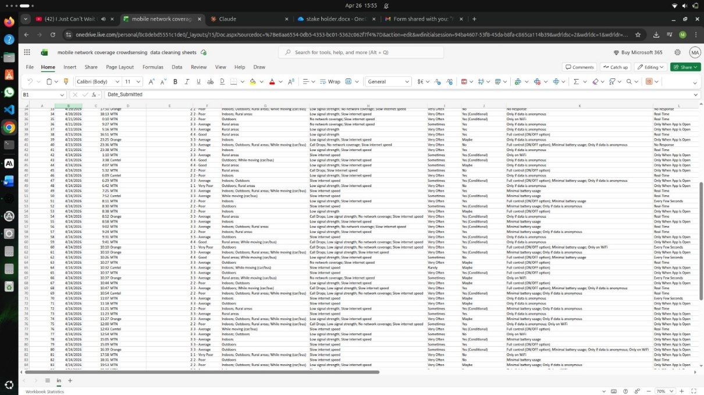

4.8 Benefits of Data Cleaning
Taking the time to clean the data before analysis provided several concrete benefits for this project:
- More accurate requirement analysis: Clear trends were easy to identify and act on once the noise was removed from the dataset.
- Reliable stakeholder insights: The cleaned data gave the team strong, evidence-based support for features like anonymity, user control, and battery efficiency.
- Better design decisions: The cleaning process pointed the team toward concrete priorities offline storage, minimal battery drain, and live coverage maps all of which are now core requirements of the system.
- Reduced risk: By resolving ambiguities in the data before analysis began, the team avoided the risk of building features based on misunderstood or misleading responses.

4.9 Summary
Data cleaning is not a minor administrative task it is what makes the entire requirement gathering process reliable. In this project, 100 raw survey responses were reviewed and corrected through a systematic six-step process: removing duplicates, dropping empty entries, standardising formats, normalising text, validating rating ranges, and fixing noise in open-ended responses.
The result is a clean, consistent dataset that accurately captures what stakeholders said. The findings from that dataset covering everything from network quality ratings to privacy concerns and data-sharing conditions directly informed the functional and non-functional requirements of the Crowdsensed Drive Test Mobile Application. Without this step, the analysis could have been distorted, and the system might have been designed around the wrong priorities.

5. USER ASSESSMENT AND USER RELUCTANCE

5.1 User Assessment
User assessment is the process of evaluating what users need, how they behave, what they prefer, and what feedback they give. The goal is to use that information to guide the design and improvement of the mobile application. It involves collecting data from users, understanding what they expect and where they struggle, testing how usable the app is, and measuring how satisfied they are with it.
For the Crowdsensed Drive Test Mobile Application, user assessment helps the team understand what real smartphone users in Cameroon actually want from a network monitoring app, and what would make them comfortable using it.

5.2 User Reluctance
User reluctance is when people hesitate or are unwilling to start using a mobile application. It usually comes from concerns, doubts, or a sense of risk. Even if an app is well-built, users may avoid it if they do not trust it, do not understand it, or feel it costs them something without clear benefit.
Understanding reluctance is important for this project because the app depends on users willingly sharing their phone's network data. If users are not comfortable, they will not participate, and the crowdsensing system will not work.

5.2.1 Key Causes of User Reluctance
- Privacy and data security concerns
- Lack of trust in the app or the developer behind it
- Complexity or poor usability of the interface
- Fear of cost, such as extra data usage or surprise charges
- Unclear benefits or not knowing what they get out of it

5.3 List of User Concerns
Based on the survey responses and general research into user behaviour with mobile apps, the following concerns were identified as the most common reasons users hesitate or refuse to use an app like this:
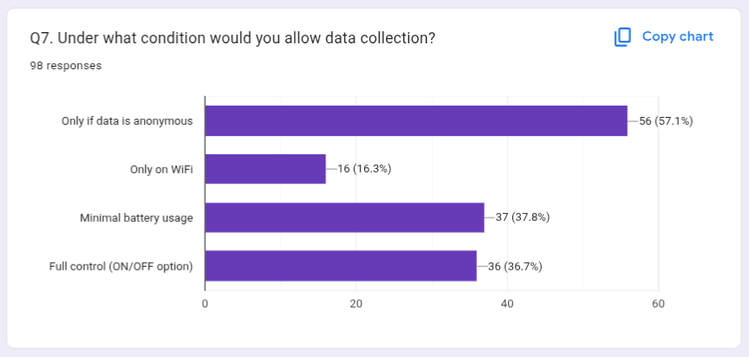
Figure 5.1: user concerns ranked by how frequently they were reported
# | Concern | Description
1 | Privacy and data security | Users are afraid their personal data could be misused or stolen if the app has poor security.
2 | High battery consumption | Background apps and services running in the background can drain battery quickly, which users dislike.
3 | Excessive data usage | Some apps consume too much mobile data because of auto-sync, updates, or high-quality media.
4 | App permissions (location, camera, contacts) | Many users are uncomfortable when an app asks for sensitive permissions, especially location and camera access.
5 | Performance issues (lag, crashes) | Frequent lag, slow loading, or unexpected crashes make users lose confidence in the app.
6 | Storage usage | Users with limited storage space are less likely to keep a large app installed.
7 | Trust in the app or company | New or unknown apps take time to gain user trust, especially when data collection is involved.
8 | Notification spam | Too many random or uncontrolled notifications frustrates users and can lead to uninstalls.
9 | Hidden costs or in-app purchases | Unexpected charges or sudden price increases discourage users from continuing to use the app.
Table 5.1: User concerns and their descriptions

5.4 Detailed Look at Each Concern

Privacy and Data Security
Users fear that their data could be misused or stolen if the app does not have strong security. Poorly secured apps can lead to data loss, identity theft, or unauthorised sharing of location information. This was the number one concern raised in the survey responses.

High Battery Consumption
Background apps and services that keep running can drain a phone's battery much faster than expected. Since this app needs to collect network data continuously or at regular intervals, battery usage is a real concern. Many users in the survey said they would only accept a maximum of 1 to 3 percent battery drain.

Excessive Data Usage
Some mobile apps consume too much data because of automatic updates, background sync, or uploading files without user awareness. For users who are on limited data plans, this is a serious issue. Several respondents mentioned they would only want the app to upload data over WiFi.

App Permissions
Many users are sceptical when apps request sensitive permissions, especially access to their location, camera, or contacts. While location permission is genuinely needed for this app to work, it is important that users understand exactly why it is needed and that they are in control of whether to grant it.

Performance Issues
Frequent lagging, slow loading times, and crashes reduce user satisfaction quickly. If users experience any of these, they will likely uninstall the app. The app needs to be stable and responsive even when running in the background.

Trust in the App
New or unknown apps take time to earn users' trust, especially when they involve data collection. Survey respondents mentioned that university affiliation and a clear privacy policy were the two strongest trust drivers for them.

Notification Spam
Notifications that arrive too often or at random times are annoying. Users who feel bombarded by alerts tend to either disable them entirely or uninstall the app. Notifications should be meaningful and controlled.

Hidden Costs
Unexpected charges or sudden increases in in-app pricing can quickly turn users away. The app should be free to use with no surprise fees, and any optional features should be clearly communicated upfront.
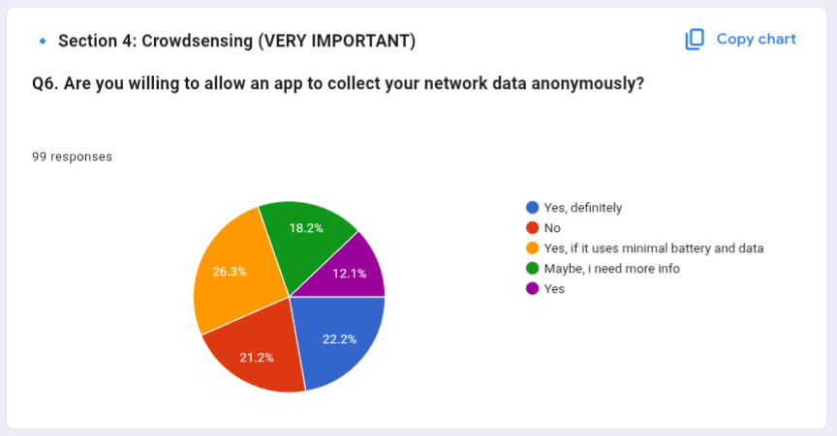
Figure 5.2: Pie chart showing respondents' willingness to use the crowdsensing app based on survey results

5.5 Proposed Solutions
To address these concerns, the following solutions were designed into the app's requirements. Each solution maps directly to one or more of the concerns listed above.

Consent System
- Use clear, transparent permission prompts that explain what each permission is for
- Tell users exactly why each permission is needed before asking for it
- Allow users to change their permission choices at any time from within the app settings

Data Anonymization
- Remove any information that could be used to personally identify a user before storing or sending data
- Encrypt sensitive data to prevent unauthorised access in case of a security breach

Settings Control
- Give users control over notifications, data usage, and background activity from a single settings screen
- Add a privacy dashboard so users can clearly see what the app is collecting and when

Performance Optimisation
- Optimise background processes so they do not slow down the phone
- Use efficient API calls to reduce unnecessary processing
- Apply battery-saving technologies so the app uses the minimum power needed

Data Usage Optimisation
- Compress data before uploading to reduce the amount of mobile data consumed
- Enable an offline mode so data can be stored on the device and uploaded later
- Allow users to limit data consumption or restrict uploads to WiFi only

5.6 Strategy to Improve User Trust
Building trust with users is not something that happens automatically. It requires a deliberate approach from the very beginning. A short strategy that guided the app's design with trust in mind includes the following steps:
Step | What It Means for This App
Be Transparent | Tell users clearly what data is being collected, why it is needed, and how it will be used. No hidden actions.
Build Credibility | The app is associated with the University of Buea and follows a clear privacy policy. This gives users a reason to trust it.
Provide Control | Users can turn data collection on or off at any time. They decide when the app is active.
Communicate Value | Users should see a clear benefit, such as helping improve the network in their area or getting access to a live coverage map.
Ensure Reliability | The app must work consistently without crashes or unexpected behaviour. Stability builds long-term trust.
Table 5.2: Five-step trust-building strategy and what each step means in practice

5.7 Statistics from the Questionnaire
From the questionnaire distributed to potential users, the following statistics were collected in relation to user reluctance and assessment. These numbers directly informed the requirements and solutions described in this section.
Question / Topic | Finding | Implication
Willingness to share data | 55% Yes, 25% No, 20% Maybe | Majority are open to it, but conditions must be met
Most important condition for sharing | Anonymity: 56 respondents | Data must never be linked to a real person
Second biggest concern | Battery drain: 37 respondents | Background sensing must be power-efficient
User control over data collection | 36 respondents want an on/off toggle | A clear enable/disable switch is required
Preferred upload method | 16 respondents prefer WiFi only | WiFi-only upload setting must be included
Acceptable battery drain | Most accept 1 to 3 percent | App must stay within this threshold
Top trust driver | University affiliation and privacy policy | These must be visible within the app
GPS data comfort | Comfortable if purpose is clear and opt-in | GPS use must be explained and user-controlled
Table 5.3: Key statistics from the questionnaire related to user reluctance and trust

6. CONCLUSION
This project set out to solve a practical and well-documented problem: the limitations of traditional drive testing as a method for monitoring mobile network coverage. By designing and implementing a crowdsensed mobile application, the team has built a foundation for a system that is more scalable, more accessible, and more representative of how users actually experience the network.
Throughout the process, the work was grounded in real evidence. Requirement gathering involved interviews with MTN network engineers, a survey of over 100 smartphone users, structured brainstorming sessions, and hands-on reverse engineering of existing applications like OpenSignal and Network Cell Info Lite. Each technique contributed something different, and together they produced a clear, well-supported set of system requirements one that covers both what the system must do technically and what users need to feel comfortable using it.
The findings were consistent and clear. Users in Cameroon experience poor network quality regularly, particularly indoors and in rural areas. Most are willing to contribute their data to help improve coverage, but only under the right conditions. They want their privacy protected, their battery respected, and meaningful control over when the app collects data. These concerns were not treated as obstacles they were built directly into the system requirements as non-negotiable design priorities.
The data cleaning process played an important role in ensuring that the insights drawn from the survey were reliable. Raw survey data contained duplicates, missing values, inconsistent formats, and mixed-language responses. Each of these issues was identified and addressed systematically, producing a clean dataset that accurately reflected what users reported. Without this step, the requirement analysis could have been skewed by noise in the data.
Looking forward, the application provides more than just a way to measure network coverage today. The data it collects, once aggregated across many users and locations, creates the foundation for something more ambitious: machine learning models that can predict where coverage will be poor before users even experience it. That prediction capability is not implemented in this phase, but the architecture and data structure are designed to support it.
In summary, this project demonstrates that a well-designed crowdsensing application can be a credible and practical alternative to traditional drive testing one that is cheaper to operate, broader in geographic reach, and more reflective of real user experience. The work done here, from stakeholder analysis through to data cleaning and system design, provides a strong and complete foundation for building and deploying that system.

